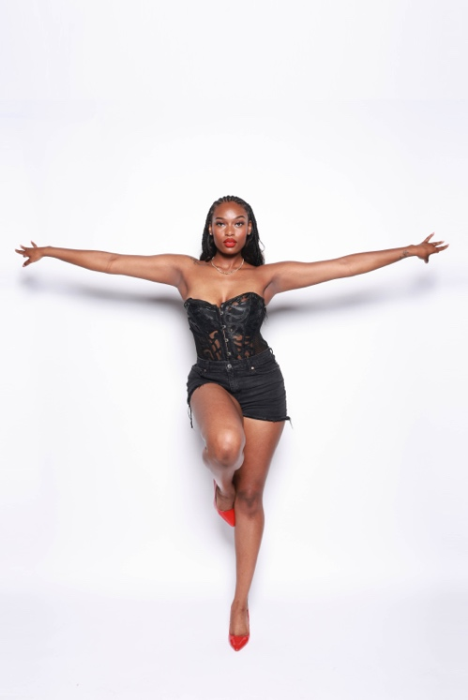
Taylor A. Duncan
(470) 218-4682 | taduncan2000@gmail.com
Savannah | Atlanta, GA
Charismatic performer who’s trained in diverse styles such as tap, jazz, ballet, heels, and hip-hop. Productive professional who’s hard working and moves with integrity and positivity.
______________________________________________________________________________
Height 5’10
Instagram: @thetayalexandria
______________________________________________________________________________

Live/Stage Performances

Hip Hop: Georgia State’s Who Got Talent (2020-2022) Atlanta, GA Dancer/Choreographer
Jazz: Georgia State’s Blu Light Café (2020-2022) Atlanta, GA Dancer/Choreographer
African: Georgia Tech’s African Night (2021) Atlanta, GA Dancer
Musical Theatre: Techmoja Dance and Theatre Company Wilmington, NC Dancer
“The House That Gordy Built” (2024)

Hip Hop: Maleigh Zan Promo Video (2024) Atlanta, GA Dancer

Hip Hop: Love and Hip Hop “Bambi” (2024) Atlanta, GA Dancer

Ballet & Creative Movement: Dance2Learn (2024) Atlanta, Ga Teacher

Heels: Jagged Edge Tour (2025) Atlanta, Ga Assistant Choreographer

Hip Hop: HBCU ADD National Conference Atlanta, Ga Assistant

Hip Hop: Atlanta Dream Hype Squad (2025) Atlanta, Ga Dancer

Production: Now Can I Do my Shhh… Atlanta, Ga Stage Hand

Training/Mentorship Programs
Coastal Performing Arts Academy Savannah, GA Dawn Kuster
Competition Team (2009-2015)

Dance Ensemble at Georgia State (2020-2022) Atlanta, GA Georgia State
Calan Bryant’s “The Pocket” (2024) Atlanta, GA Calan Bryant
SSS Mentorship Program (2024) Atlanta, GA Sakinah LeStage
The Lyrik London Project Mentorship (2024) Atlanta, GA Lyrik London

